

dance moves people: our 10-year strategy

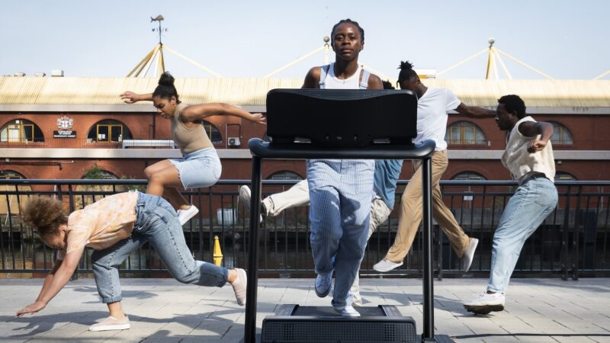  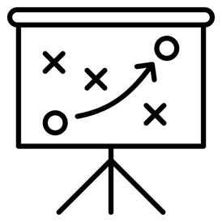  2025 – 2035 | We are a dance organisation.  We believe dance is important. We want everyone else to understand that too.  This is our ten-year plan to help make that happen.

 | What do we want?
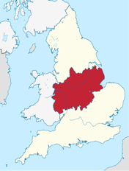  This Photo by Unknown Author is licensed under CC BY-SA | We want the Midlands to be famous and respected for dance all over the world because this is where we are.
 | We will do these things...:
 | help dance grow and develop...
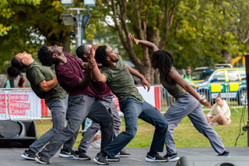 | work with dancers and communities to celebrate all dance cultures...
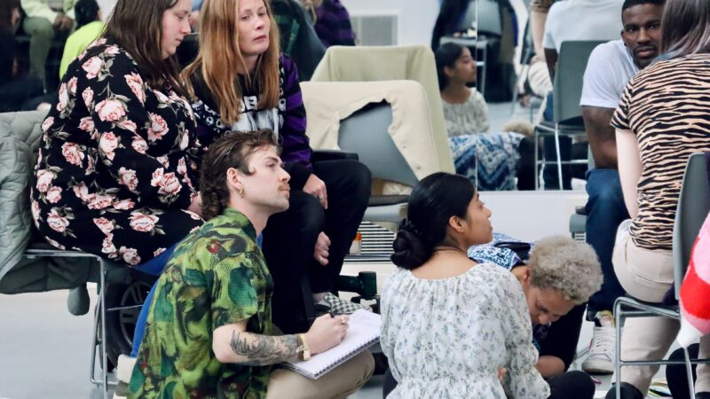 | work with people who are passionate about their ideas...
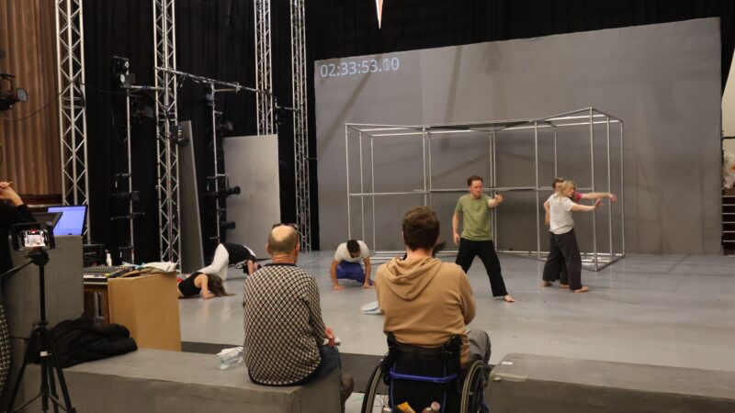 | support people who are working in the dance industry...
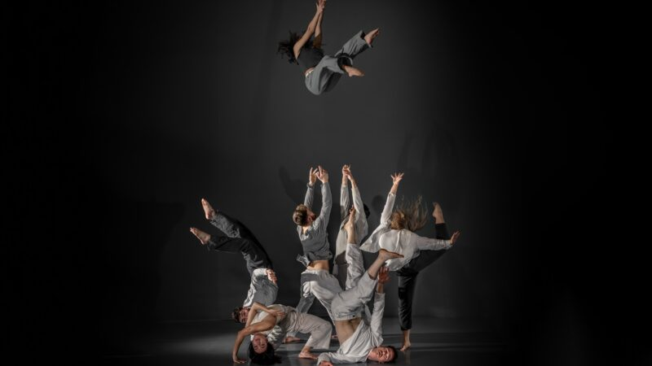 | work with dancers and choreographers who make us think and feel differently...
 | work with dancers and choreographers who embrace our values:  - curiosity  - disruption  - joy
 | support dancers and choreographers who live and work in and out of the Midlands...
 | And work nationally and internationally to share learning.
 | How will we do this?
 | Research: Ask lots of questions about what dance is and what it can be.
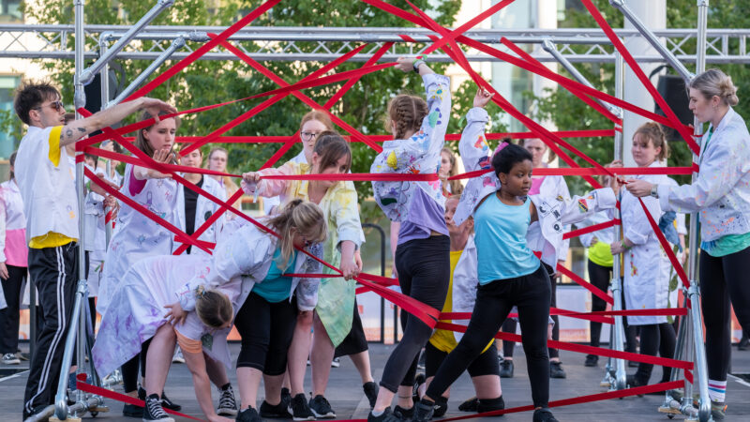 | Engagement: Introduce dance to people of all ages, abilities and backgrounds
 | Dance Industry Development: Help the dance industry to grow and develop through investment and partnerships
 | Presentation and Showcasing: Showing different dance performances and events, here and sometimes in other countries
  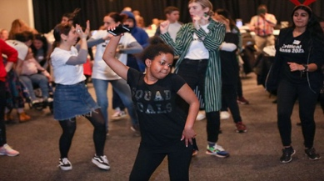 | 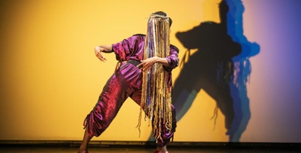
  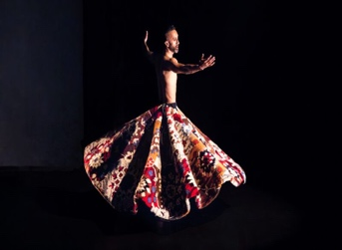 | 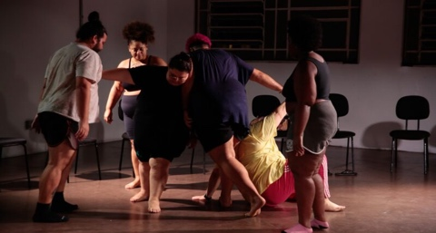
 | We will do this through:  - care  - being open to thoughts and ideas  - and working hard to do things well
 | What does that mean?
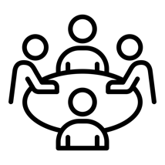   | This means our work includes:  - Classes and workshops  - Training and professional development  - Research  - Performances and conferences  - Supporting dancers and choreographers of all ages  - Working with international partners
 | We also want to be brave enough to admit when something is not working
 | And finally, to ask the question ... what can dance be?
 | What resources will this take?
    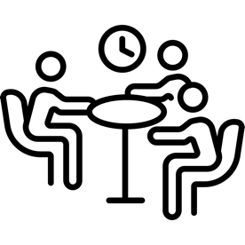 | Our success depends on our people, partnerships, and communities.  We have strong financial support from Arts Council England and some other funders. We also earn money from ticket sales, participation fees, studio hires, and project commissions.  We have people and systems in place to make sure we are doing well and question us about our plans  We offer dance and rehearsal studios, shared workspace, and meeting rooms in Birmingham and Nottingham.
  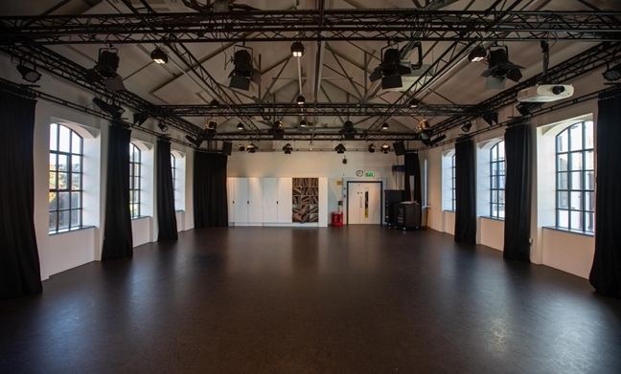
 | Monitoring and Evaluation
           | We will check how we are doing to make sure we meet our goals and learn from our experiences.  We will do this with specialist help.  We will also use this learning to keep up to date and informed on:  - The economic value of the dance sector  - The physical & mental health and wellbeing of all people working in dance  - Audiences  - Equality, Diversity and Inclusion  - Environmental Sustainability  We will remain curious and share what we learn.
         | This plan shows our commitment to listening, supporting, and making positive changes.  It is an outline of what we have understood through many conversations and shows that we will continue to listen, support, influence and affect change.  For further information on our activities, please visit www.fabric.dance  For the full version of this strategy, please visit: QR code  To offer your comments on this strategy, we welcome emails to info@fabric.dance

Glossary - Wordlist and meanings from this document

Page 1

Strategy - this is another word for plan.
dance moves people - these words describe what we think about dance, but it can mean different things to different people.

Page 2

Dance Cultures – different forms of dance in every society and community

Page 3

Choreographers – create dance and teach it to others
Curiosity – really wanting to know more
Disruption – changing something to make an impact
Joy – a feeling of great happiness

Page 4

Research – finding out about dance as an art form
Engagement – involving people in opportunities to dance

Page 5

Classes – dance classes of all kinds for all ages, interest and ability
Workshops – for people who want to learn more about dance
Professional Development – training to help people who work in, or want to work in, dance
Performances – in theatres, in other venues, and/or outdoors

Page 6

Resources – our people, our buildings and our money
Systems – ways of doing things
Page 7

Monitoring and evaluation – how we check our progress
Specialist – someone who is an expert in their job
Economic value – measuring how much the dance industry is worth
Physical – how someone is feeling in their body
Mental health – how someone is feeling in their mind
Wellbeing - how someone is feeling comfortable, healthy or happy
Equality, Diversity and Inclusion - treating everyone fairly, celebrating what makes each of us all different, and making sure everyone feels welcome, safe and respected.
Environmental Sustainability – looking after the environment

Page 8

Commitment - promise
Outline - summary

