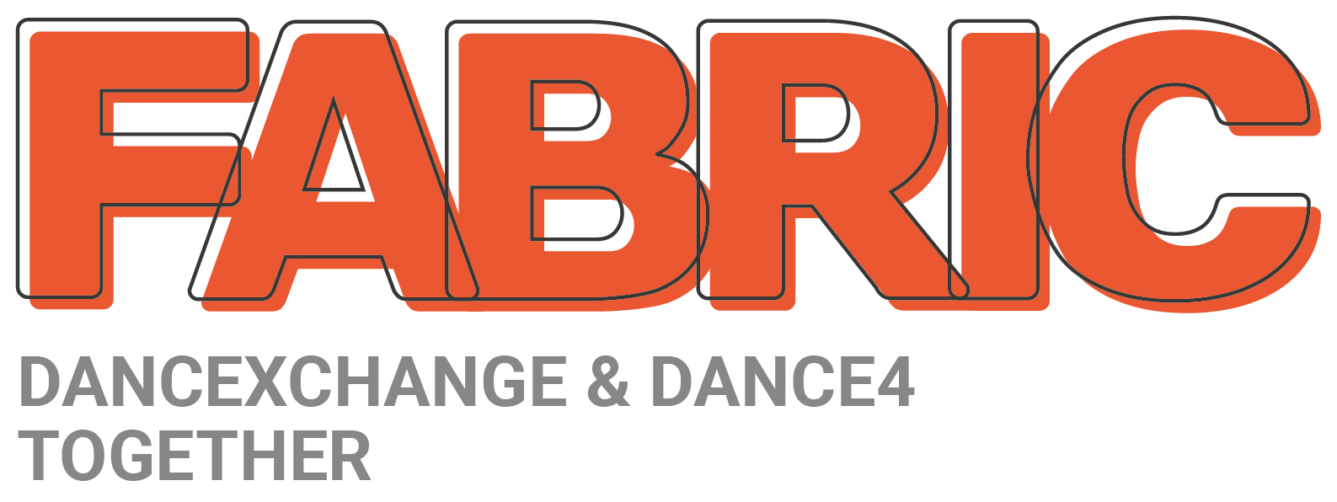

Registered Charity 1196368

We need your help to continue to deliver extraordinary dance experiences.
Please make your donation go further by making a Gift Aid declaration for donations.

Please tick one of the following boxes:

I want to Gift Aid my donation of £______ and any donations I make in the future or have made in the past 4 years to FABRIC

I want to Gift Aid my donation of £______ to FABRIC

I am a UK taxpayer and understand that if I pay less Income Tax and/or Capital Gains Tax than the amount of Gift Aid claimed on all my donations in that tax year it is my responsibility to pay any difference.

I understand the charity will reclaim 25p of tax on every £1 that I donate.

Donor’s details

Title _______First Name _________________Surname __________________________

Full home address ________________________________________________________________________

________________________________________________________________________

Postcode ___________________ Email ______________________________________

Date _________________ Signature ____________________________________

Please notify us if you:
- want to cancel this declaration
- change your name or home address
- no longer pay sufficient tax on your income and/or capital gains.

If you pay Income Tax at the higher or additional rate and want to receive the additional tax relief due to you, you must include all your Gift Aid donations on your Self Assessment tax return or ask HM Revenue and Customs to adjust your tax code.

Return by post to:
FABRIC, Level 5, Birmingham Hippodrome, Thorp Street, Birmingham, B5 4TB
Or email to: finance@fabric.dance with the subject line: GIFTAID

